**104KM Enterprise Information Systems**

**Tutorial Activity – Week 4**

**Short Questions**

1. List the phases of Software Development Life Cycle (SDLC).
2. Match the following skills of the **System Analyst**.

|  |  |
| --- | --- |
| Analytical Skills | Working alone and with a team and facilitating groups |
| Management Skills | Interviewing, listening, written and oral presentations |
| Technical Skills | Decomposing project into independent tasks and determining relationships between tasks |
| Interpersonal Skills | Problem identification, analyzing and solving |
| Communication Skills | Requires continuous learning and keeping skills up-to-date |

1. List different types of Information Systems.
2. What are the components of the Database Management Systems (DBMS)?
3. Give five advantages of using a DBMS and list three applications of DBMS?

**SQL LAB 1 - Building a Database**

Connecting to SQL+:

* Launch Oracle 11g with SQL+ from *AppsAnywhere*
* Wait until the SQL prompt appear and type the following command to connect to SQL

**SQL> connect /@acal**

* To exit from SQL, type the following:

**SQL> quit**

**Task 1: Create table for use in subsequent labs**

Create departments, employees, jobgrades based on the structure of each table shown below:

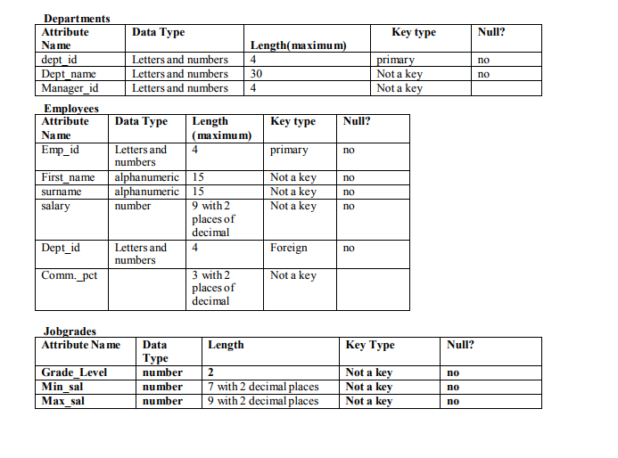

**Task 2: Add the data given for each table using INSERT command.**

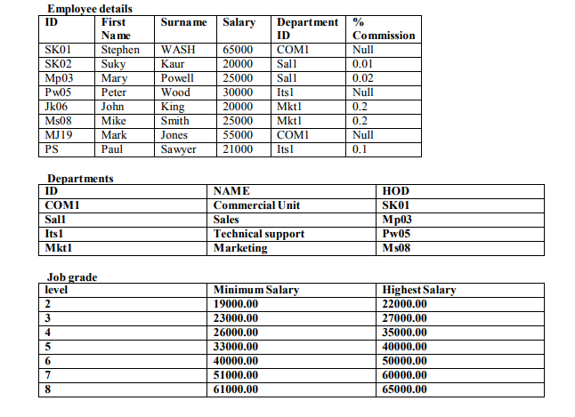

**Task 3: Remember to save your work by typing COMMIT**